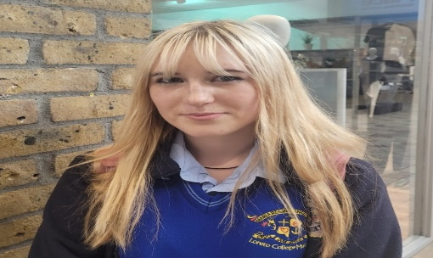
The issue of the voting age is in the news again, with the Minister for Housing and Local Government Darragh O’Brien sending a letter of request on the 19th of July, to the Electoral commission’s chairwoman, Ms Justice Marie Baker regarding lowering the voting age to 17, according to the Irish Times. In response, some people of County Westmeath had this to say.
Vakare Aranuskaite thinks that people who are 17 years old are “not mature,” to make these decisions along with saying, that voting at 17 is “not really traditional.”
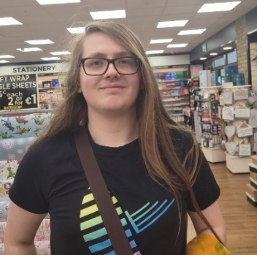
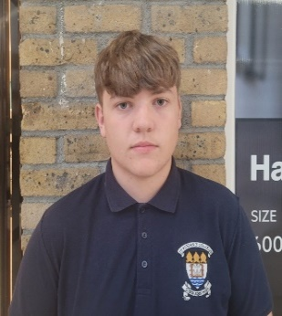
Sam McMally, 16, feels that the age to vote should stay at 18 years old, since he believes that at 17 you would not be “mature enough to make important decisions for councils and vote for presidencies.”
Vakare Aranauskaite a student of Loretto College
Naoise McManus, a student in Maynooth university
Sam McMally, a student of ST Finian’s College


Naoise McManus, 19, from Kinnegad, thinks that the voting age should actually be “lowered to 16 years old.” Naoise believes that this would then give students the opportunity to share their opinions on who should be their Minister for Education, since this position directly impacts student lives. Naoise also pointed out, that after the completion of the Junior Cert, people can leave school, get a “full time job”, and contribute to society by paying taxes, and therefore deserve the right to vote.
Leo Dowling, believes that the age of voting should stay at 18 since he believes that “until kids get into third level” education they wouldn’t have enough experience to make good decisions.
John O’Toole
Leo Dowling
John O’Toole, also feels that 18 year olds would have a more “mature outlook” after finishing second level than younger people.

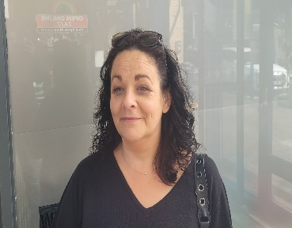

Elaine Dowling, expressed the opinion that if more young people were given a chance to vote, then they would have “more of an interest in the country.”
Tom Brennan, believes that the age of voting should be lowered for the young people who do really “care about politics,” while also helping them “know what they are voting for.”
Tom Brenan
Elaine Dowling
It seems that the main consensus around Mullingar is that people who are 16 or 17 are still too young to take part in elections until they mature more and completed second level education.
According to the Irish times, the Coalition will legislate for Darragh O’Brien’s request “in advance of the 2024 local election.”

